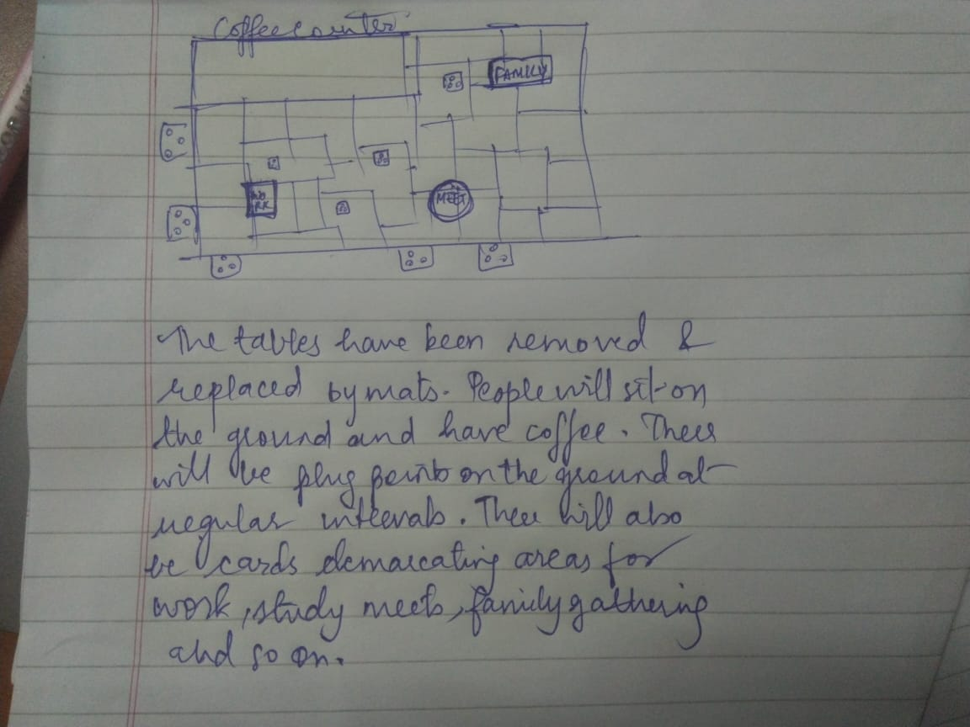

Component removed – Tables and sofas

Component added - Large number of mats are placed on the ground

There will be plug points placed on the ground

There will also be placards demarcating sections as work, study, meeting, family gathering and so on so people with the same interests and sit nearby and interact with each other.